iBOX & AiRBOX - Revoluionize Your AV Experiences
In recent years, with the prevalence of IoT and AI, the digital signage becomes the best solution in terms of promoting company’s image, product sales and efficient digital marketing. Since 2005,
t-WIN has been excelling in Custom IC/System design and total AV solution. Based on the solid technical background, t-WIN provides one-stop-shopping AV solution. In April 2017,「360 degree Irregular TV Wall」and its processor「tv-WALL199U」comes out. See Fig I below.「iBOX」implements irregular tv wall and makes digital signage second to none. See Fig II below. Nowadays, most schools prefer cloud classroom, with「360 degree Irregular TV Wall」, it can enhance the learning interests of students and attains flip learning. See Fig III below.「iBOX」supports HDMI interface, full HD image and video output and Digital Signage of all brands, numbers and sizes. With USB connecting to computer, user can use user-friend interface, GUI and move image vertically, horizontally or any angle one wants. It can correct image automatically if the size of images do not fit into the Digital Signage. Besides, users do not need to buy specified server, AV equipment and LED Display Module to support image and video output. t-WIN provides customization of iBOX, which can meet the demand of all kinds of environments and requirements. Most importantly, there’re no limitions on the number of display that you can set up in the irregular TV Wall. Many-to-many design allows users to unveil galloping imagination in the life.
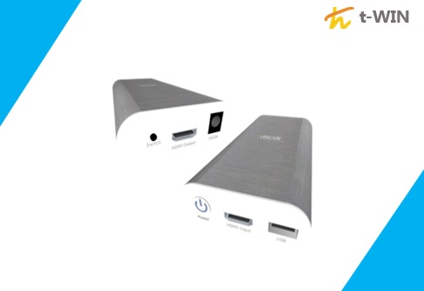
(FIG I.)「iBOX」is handy and light. 61 x 155 x 27(mm)/165g
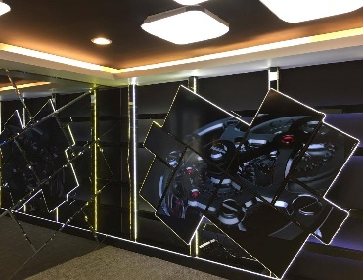
(FIG II.) Unique irregular video wall array
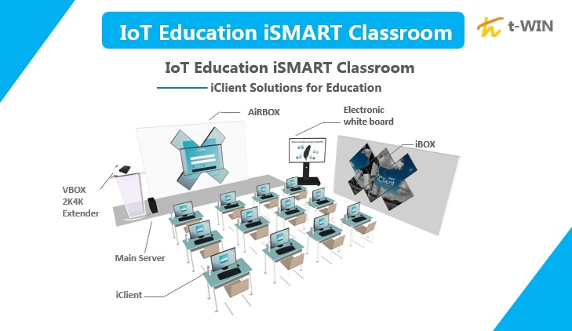
(FIG III.) It fits in iSmart Classroom
With our unique design in iBOX, we integrate AI, VR and AR into IoT Education iSMART classroom and we will release the newest product「AiRBOX AI 360 degree Rotation Irregular TV Walls Solution」in September 2017.「AiRBOX」adopts ADC technology and Rotation module, combined with iBOX, and breaks confinement rules. It can meet all kinds of requirements – any degree you want. Therefore, it can impart all new visual experiences and benefit the economy of attention to the utmost. We expect「AiRBOX」to bring another fad. See Fig IV below. The 360 degree rotatable feature makes
students’ learning processes much more effieient and fun.

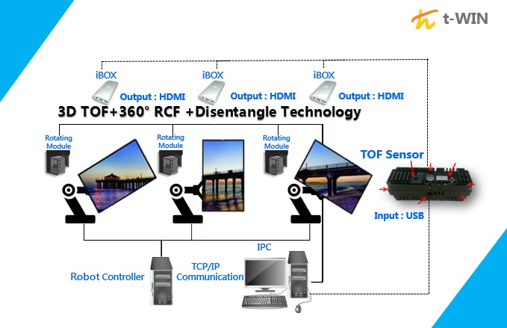
(FIG IV.) With Rotation module and iBOX, users can make display rotate 360 degrees.
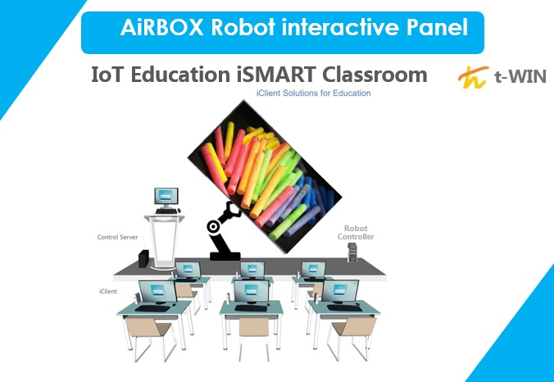
(FIG V.) AiRBOX’s 360 degree rotatable monitor makes learning much more fun
In the future, t-WIN is expected to implement Big Data in the market. The AI sensor can collect data from consumers, and thereafter predict consumers’ taste and habites. It will allow digital marketing to be much more smarter and efficient. For instance, if one user would like to
control remotely their displays located in different areas, and acquire automatically the information form consumers and their shopping behaviors,「AiRBOX」transmits data to cloud computing centre, in which monitor will cater to the taste of consumers automatically and display their most desirable product commercial. See fig VI。
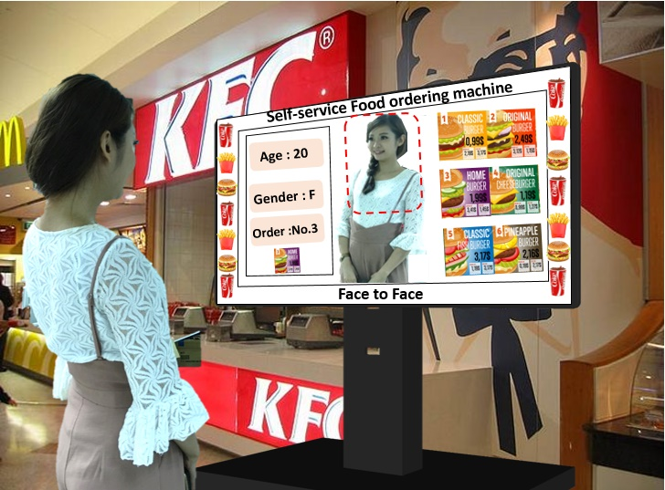
(FIG VI.) Possible futuristic product.
t-WIN has prepared the comprehensive future roadmap for the prevalent trend of IoT, and we consider Digital Signage has changed the core value of commercial industry. Based on Big Data, Cloud computing and IoT, Digital Signage can be used almost in all kinds of area. It provides smart and high-efficient service for manufacturing, retailers, education, exhibition, transportation, Motel, department stores, shopping malls and hospital…etc. For company,「iBOX」and「AiRBOX」solution are the best instrument for expanding its niche market!
t-WIN will join 2017 Touch Taiwan during 20-22 Sept (Booth: N814 )and infoComm Mumbai during 26-28 Sept (Booth @40). We sincerely invite you to our booth. More info. http://www.t-win.com.tw/ You can get more outstanding products. http://ibom.t-win.com.tw/

